Lecture No.10 PARASITOLOGY DR.Raad H.H.
Order Enoplida
Consists of 4 Families Trichinellidae ; Trichuridae ; Capillaridae Dictyophymidae.

General characters
- General form very small size whip or hairy worms.
- Female oviparous Trichinellidae; Trichuridae
- Esophagus form cellular (Stichosome )
- Male reproductive system No copoulatory bursa ; but have posterior end with 1 spicule.
- Egg barrel , lemon shape with 2 polar plugs structure with undivided embryo.
- Life cycle Direct (Trichuriidae) or indirect (Capillaridae)
- Infective stage - Eat meat with L₁ or Swallow egg with L₁ or
Swallow earth worm with L₃.
Family Trichinellidae
Characterized by :
- habitats small intestine mucosa of mammals, Human ,pigs and rodents.
- genus Trichinella .
- speices Trichinella spiralis .
- zoonotic nematode .
- larvae spiral form contained in cysts in the muscles.
- It causes a disease called Trichinosis.
Pathology and Immunology:
Trichinella pathogenesis is due the presence of large numbers of larvae in vital muscles and host reaction to larval metabolites. The muscle fibers become enlarged edematous and deformed. The paralyzed muscles are infiltrated with neutrophil, eosinophils and lymphocytes. Splenomegaly is dependent on the degree of infection. The worm induces a strong IgE response which in association with eosinophils contributes to the parasite death.

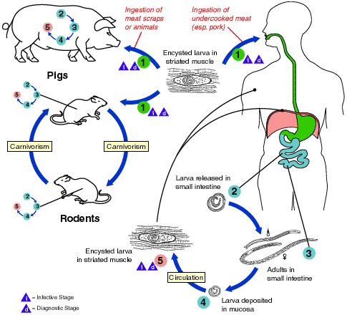

Life cycle : Trichinosis is acquired by ingesting meat containing cysts (encysted larvae) (1) of Trichinella. After exposure to gastric acid and pepsin, the larvae are released (2) from the cysts and invade the small bowel mucosa where they develop into adult worms (3) (female 2.2 mm in length, males 1.2 mm; life span in the small bowel: 4 weeks). After 1 week, the females release larvae (4) that migrate to the striated muscles where they encyst (5). (Trichinella pseudospiralis, however, does not encyst). Encystment is completed in 4 to 5 weeks and the encysted larvae may remain viable for several years. Ingestion of the encysted larvae perpetuates the cycle. Ratsand rodents are primarily responsible for maintaining the endemicity of this infection. Carnivorous/omnivorous animals, such as pigs or bears, feed on infected rodents or meat from other animals. Different animal hosts are implicated in the life cycle of the different species of Trichinella. Humans are accidentally infected when eating improperly processed meat of these carnivorous animals (or eating food contaminated with such meat).
- Diagnosis:
- Symptoms .
- Diagnosis is based on symptoms, recent history of eating raw or
undercooked meat .
- laboratory findings (eosinophilia, increased serum creatine phosphokinase and lactate dehydrogenase and antibodies to T. spiralis).
- Biobsy for microscopic exam .to find larvae under compression or digestion by ” Trichinoscope”.
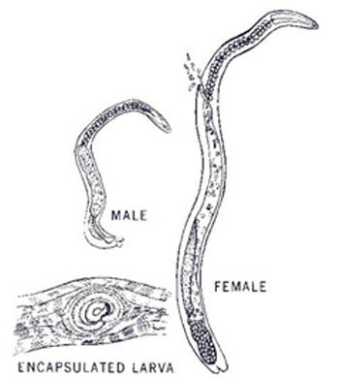

Family Trichuridae
Characterized by :
- Genus Trichuris
- "Whipworm" habitats large intestine of mammals.
- It is so called since the anterior parts of the body is long and slender while the posterior part is thicker and much shorter.
- Tricuris trichura in human ;T. ovis in sheep in cecum of cattle sheep and goats
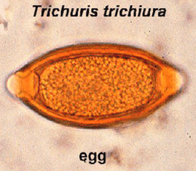

- The hind end of male is curled and there is one spicule with a protrusible sheath which bears spines and a oblong swelling.
- Eggs are barrel shaped with double plugs.
- Direct- eggs hatch after being ingested by definitive host.
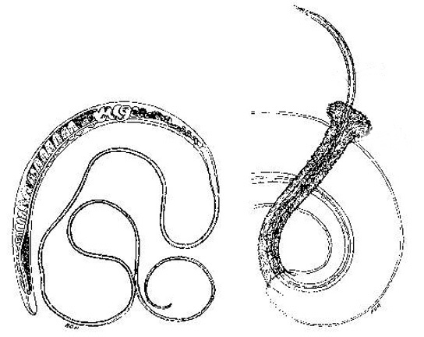

Family Capillaridae
Characterized by :
- genus Capillaria
- habitats large intestine of birds &mammals
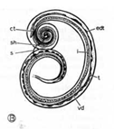
- Capillaria bovis Species occurring in the small intestine of cattle, sheep, and goats. Capillaria obsignata

- The above two species belongs to a group of nematodes which are closely related to Trichuris, however, they are small and slender and the posterior part of the body is not conspicuously thicker than the anterior part.
- The life cycle of species found in mammals is direct where as some of the life cycles of those found in fowl are indirect.
- Eggs are double plugged.

